County Councillor Update  Coker Division SCC  Cllr Mark Keating  June 2021 |  | 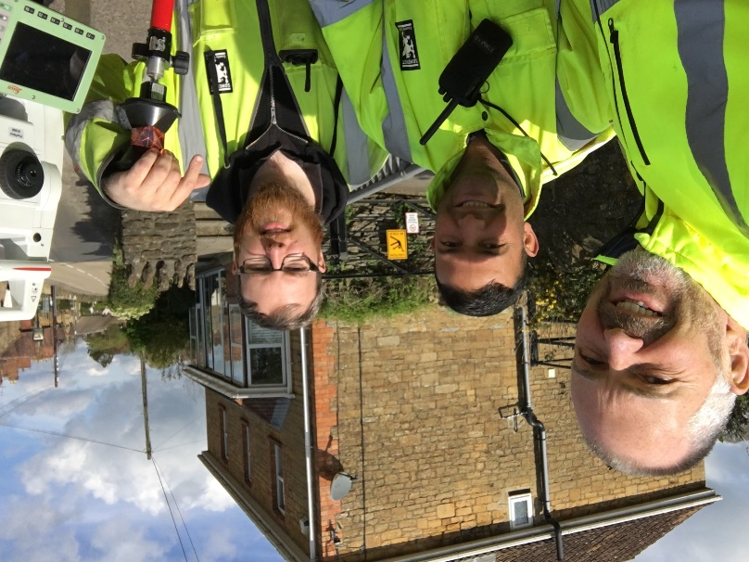
Representing you in - Barwick, Chiselborough, Closworth, East Chinnock, East Coker, Hardington Manderville, Hardington Marsh, Hardington Moor, Haselbury Plucknett, Middle Chinnock, Montacute, North Coker, North Perrott, Norton Sub Hamdon, ​Odcombe, Pendomer, Sutton Bingham, Stoford, West Chinnock, West Coker.
Useful Contacts Resources and Websites: Somerset Coronavirus Support Helpline: 0300 7906275
Cllr Mark Keating – Somerset County Council | E: MAKeating@Somerset.gov.uk | M: 07767 203968
South Somerset Area Highways Office | E: countyroads-southsom@somerset.gov.uk | T: 0300 123 2224
Report Pothole/Road Defect | E: roadsandtransportSD@somerset.gov.uk | T: 0300 123 2224
Report Dead Animal/Mud on Road | E: roadsandtransportSD@somerset.gov.uk | T: 0300 123 2224
Neil McWilliams – Highways Service Manager | E: countyroads-southsom@somerset.gov.uk | T: 0300 123 2224
Lee Norman/Derek Davies – Assist Highways Service Manager | E: countyroads-southsom@somerset.gov.uk | T: 0300 123 2224
Garry Warren/Rebecca Vaughan – Traffic Engineer. Traffic & Transport Development | E: countyroads-southsom@somerset.gov.uk | T: 0300 123 2224
Gully Emptying / Road Sweeper | E: chris.holley@southsomerset.gov.uk | T: 01935 462462
Nick Allen – SSDC Ranger Scheme | E: nick.allen@southsomerset.gov.uk | T: 01935 462462
Road Records & Highway Licensing | E: Roadrecords@Somerset.gov.uk | T: 0300 123 2224

Report Adult at Risk | adults@somerset.gov.uk |  |  | T: 0300 123 2224  T: Emergency: 999
Report Child at Risk | childrens@somerset.gov.uk |  |  | T: 0300 123 2224  T: Emergency: 999
Children’s Social Care Worker out of hours Emergency Duty Team |  |  |  | T: 0300 123 2327
Fostering and Adoption www.fosteradoptsomerset.org.uk | AandFRecruitmentEnquiryLine@somerset.gov.uk |  |  | T: 0800 587 9900
www.somersetwaste.gov.uk |  | ssdc@southsomerset.gov.uk | T: 01935 462462
https://www.travelsomerset.co.uk/ |  | Travel - Drive Bus Train Walk Cycle Weather
www.somerset.gov.uk |  | generalenquiries@somerset.gov.uk | T: 0300 123 2224
http://roadworks.org/ |  | Useful website for road works info
www.facebook.com/somersetcountycouncil |  | Somerset County Council Facebook page
https://roam.somerset.gov.uk/roam/map |  | Interactive Rights of Way Map / maintenance reporting
Coronavirus infection rates: As at 28th May the number of confirmed Covid cases in Somerset was 20,455 (up from 20,272 on 30th April) and the number of Covid-attributed deaths 800 (796). The rate per 100,000 stands at 5.5 for Somerset with Mendip at 5.2, Sedgemoor at 8.9, South Somerset 3.6 and SW&T at 5.2. The number of total deaths across the County is currently 8% below the 5-year average and the latest R-value for Somerset is between 0.8 and 1.1.

Despite significant progress and even those who have had both jabs it is vitally important to remember, to observe Hands-Face-Space and to Ventilate indoor areas at all times.

Road map out of lockdown: The final stage out of lockdown due on (or after) 21st June is subject to Government assessment on four key criteria:
- the vaccine deployment programme continues successfully
- evidence shows vaccines are sufficiently effective in reducing hospitalisations and deaths in those vaccinated
- infection rates do not risk a surge in hospitalisations which would put unsustainable pressure on the NHS
- the assessment of the risks is not fundamentally changed by new variants
By this date the Government hopes to be in a position to remove all legal limits on social contact and to reopen remaining premises, including nightclubs. The easing of restrictions on large events, performances and life events such as weddings will also be subject to the analysis of the outcomes from certain pilot events.
Somerset Coronavirus Support Helpline: A single phone number continues to be available for anyone in Somerset who needs Coronavirus-related support. 0300 790 6275, is open seven days a week from 8am to 6pm.

Vaccination programme roll-out: Somerset has one of the highest vaccination rates in the country with the latest figures showing 324,147 having received at least their first vaccination or 77.5% of the 16+ population. 246,983 (53.3%) have received their second dose. Take up rates of both doses is very high: 80+ (95.8%), 75-79 (100%), 70-74 (97.7%), 65-69 (86.2%), 60-64 (73.0%), 55-59 (50.4%) and 50-54 (47.4).

One Somerset: An announcement on the future of local government in Somerset is expected from the Government in late June/ early July. For more information visit: www.onesomerset.org.uk

Extra investment into Public Health: Somerset County Council is allocating an additional £10m to embed public health across all areas of council services. The major investment will include £2m to support Somerset communities – helping address anxiety and those with mild mental health issues. £2m expanding Somerset’s expert health protection programme including controlling outbreaks, managing testing, providing localised contact tracing, and supporting businesses and communities. Some funding will be invested in research and work to improve local understanding of Covid and the changing needs of the Somerset. A further £500,000 will be made available for town and parish councils to help them reconnect with their communities by safely reopening facilities like halls, rooms and other sites with good prevention control measures in place.
Summer activities for Years 11: Somerset students heading from Year 11 into Year 12 will have access to a wide range of free exciting educational opportunities this summer. There is a mixture of virtual and face-to-face events and activities to choose from taking place across the county including Kilve Court, Charterhouse, and other key venues across Somerset. These will include team-building exercises and physical activities such as climbing and low-ropes, as well as wellbeing and ‘ready to study’ sessions. Registration is now live via: www.somersetworks.vfairs.com
Rights of Way: During the COVID-19 pandemic there has been a big rise in the number of people using the county’s 9,000 public rights of way across the network which totals 3,843 miles (6,186 km). This has meant a huge upsurge in the number of reports being received; at times double that from previous years. Through the Rights of Way team and nearly 400 volunteers the network’s ‘easy to use’ grading has risen to 85.7%, the highest since records began in 2003 when the percentage was just 39.2%. For anyone interested in helping the team you can find out more about at www.volunteering.somerset.gov.uk
Donate a toothbrush: National Smile Month (which runs to 17th June) is the world’s largest and longest-running campaign to promote better oral health. It aims to promote key tips and advice, helping keep everyone’s smile healthy. This year Somerset County Council is encouraging people to think about adding a toothbrush and toothpaste when they donate food to their local Foodbanks. Poor oral health is largely preventable and good habits of brushing twice a day should be taught from when a baby’s first tooth shows through.
New School for Special Educational Needs and Disabilities: Construction has finished on Polden Bower School, a brand new £23m Somerset County Council-funded state-of-the-art school in Bridgwater which is clearly visible from the M5. The project is part of a wider SCC’s programme to boost provision for children and young people with Special Educational Needs and/or Disabilities (SEND) in the county and caters for 160 students aged 4-16 with complex needs. Primary aged children are due to start on site in June, with older children following in July so that they get the accustomed to their new environment before the start of the new school year in September 2021.
Winter Gritting Summary: In the 2020/21 winter season SCC’s fleet of 23 gritters were needed on 66 occasions when freezing temperatures were forecast, treating around 900 miles of road each time to help prevent ice forming. This included additional gritting to ensure safe passage to vaccination and testing sites. The team covered 70,200 miles, a significant increase from previous years when they covered 44,000 miles in 2019/20 and 32,800 miles in 2018/19. The lowest road temperature was recorded at -6.1 degrees in the Mendip Hills on 10th February 2020.

